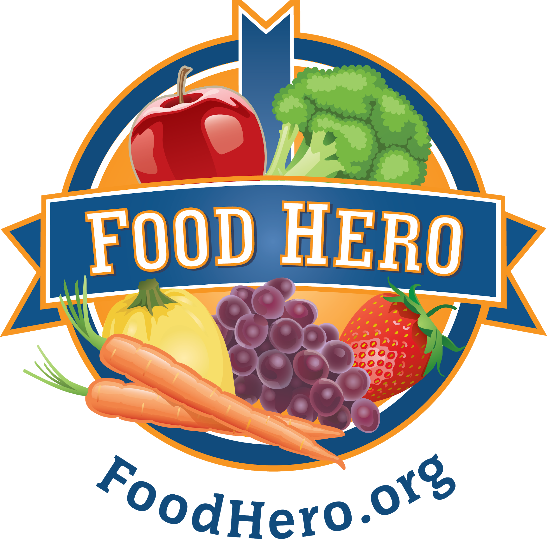

HEALTHY SCHOOL CELEBRATIONS

Table of Contents
The Oregon State University Extension SNAP-Ed Program’s Healthy School Celebrations is designed to bring healthy foods and fun activities together at school to make healthy habits the norm. The Healthy School Celebrations strategies assist schools to provide consistent messaging around the school food environment and align with Oregon School Wellness policy best practices.

Section 1: Overview of Materials

- Healthy Celebrations Kit Contents
- Resource Guide Introduction
- Healthy Celebrations Sample Snack List
- Sample Parent Letter - Healthy Celebrations Policy Announcement (English/Spanish)
  - Templates available at https://foodhero.org/celebrations
- Sample Parent Letter – Healthy Celebrations Ingredient Donation (English/Spanish)
  - Templates available at https://foodhero.org/celebrations

Section 2: Recipes and buying guides

- Food Hero Recipe Packet & Buying Guide

Section 3: Additional support materials

- USDA 10 Tips – Be Food Safe (English/Spanish)
- School Snacks: Food Hero Monthly Special Edition (English/Spanish)
- Healthy and Fun Celebrations: Food Hero Monthly Special Edition (English/Spanish)
- Find more optional supplemental materials at https://foodhero.org/celebrations

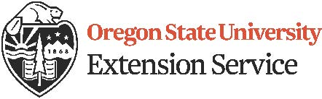

©2019 Oregon State University Extension Service offers educational programs, activities, and materials without discrimination based on age, color, disability, gender identity or expression, genetic information, marital status, national origin, race, religion, sex, sexual orientation, or veteran’s status. Oregon State University Extension Service is an Equal Opportunity Employer.

