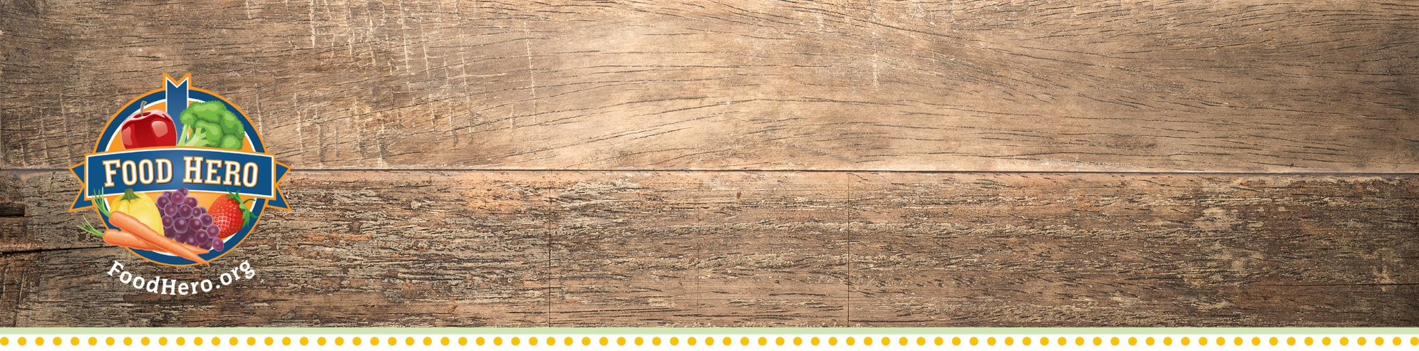
Directions to Kids Art Contest
Food Hero Kids Art Contest Directions

All Kids Art Contest files can be found in the Food Hero Community Toolkit: http://foodhero.org/kids-art-contest Questions? Email Us: food.hero@oregonstate.edu

- Contact your school or community partner and ask if they are interested. If so, make sure teachers are made aware of project too.
- We ask that on the back of each drawing, you add 1) Childs first and last name 2) Age 3) Teacher 4) SNAP-Ed educator 5) School 6) County. To make this faster, we suggest you print this out with the information on numbers 3, 4, 5 & 6 already typed out for them. This template is found here http://foodhero.org/kids-art-contest called Template for Kids Artwork, printed on 8 ½ x 11 paper.
- Print and drop off the respective number of copies for teachers interested in participating, along with the Artwork Consent Form (available in English and Spanish). Make sure to remind teachers that kids will draw on the blank side. If you don’t want to drop off, you can add this to a curriculum lesson or have at an event.
- Suggestions for artwork are listed on the main section of this page http://foodhero.org/kids-art-contest. These are just suggestions of foods we don’t have, but kids can draw anything.
- We will accept artwork at any time!
  - The best artwork for use is boldly colored – with color in the background. (White backgrounds are difficult to scan in high resolution).
  - We love seeing different art forms -- collage, watercolors, pastels, colored pencils, crayons, etc.
  - Text on the artwork is usually distracting -- or illegible. Please discourage too much writing on artwork. Using 8 ½ x 11 paper, format can be landscape or portrait.
- Collect the artwork and the signed consent form, and send to Lauren Tobey on campus OSU, 106 Ballard Hall, Corvallis, OR 97331. Paperclip the consent form to each respective artwork.
- Campus will review, and if a student is found a winner, they will receive a Food Hero Campion Award and a reinforcement from campus.
- Campus will send back to the SNAP-Ed educator all copies with consent forms. The SNAP-Ed educator can pass them back out to kids to take home.
10. Report it, in NEP online. How you report youth audience art contest activities under the site-level intervention reporting tab depends on the context:
- If you do an activity with the art contest (e.g. link it to healthy eating messaging through a series, stand-along session, additional activity, or a Food Hero-themed event), report as follows:
  - For direct education, include an ‘additional activity’, and select ‘Food Hero Social Marketing Activity’ for that group. The session that includes an in-class activity around the art contest should have ‘Art Contest’ listed in the title and/or the notes section. Unless the art is returned during that session (i.e. it is an in-class project), be sure to select ‘yes’ for Education Materials Sent Home.
  - For an event at which art contest sheets and instructions are handed out/made available, you will want to select ‘Food Hero Social Marketing Activity’ as the theme, and any other theme of the event. In the notes, you may want to indicate if the contest sheets were filled in at the event (as part of the event), or sent home to be returned to you at a later date.
- If you are simply dropping off art context supplies/instructions to a site partner to distribute, you would select ‘ed materials sent to site’, and name the materials ‘art contest’; be sure to select ‘Food Hero- themed’.

