Healthy Celebrations Ingredient Donation

[Date]
Dear 4th Grade Families,
Our school is participating in the Oregon State University Extension Food Hero Program’s Healthy School Celebrations, an initiative that is helping us make our school a healthier place. Creating a healthy school for our students is important because we know that healthy students are better learners. One of our goals is to create new celebration traditions at our school, and we are asking for your help.
We want to send a consistent message about good nutrition and healthy eating, so it is important that our celebrations reflect the healthy changes being made throughout our school. Between holidays and birthday celebrations, the number of high fat, sugary foods and beverages a student consumes during the school year can add up quickly. With a few easy changes our school community can help shift the focus of school celebrations from food to healthy fun.
For our upcoming [name] celebration, we will be preparing a Food Hero recipe in class. Parents who would like to contribute one of the recipe ingredients (listed below) are welcome to sign up with me, or provide another snack from our Healthy Celebrations Snacks List.
Please contact me with any questions. Thank you for helping us create a healthier place for your child to learn!

Sincerely,
[Teacher Name]
[Teacher Email]

[Food Hero Recipe Name]
Ingredient
Ingredient
Ingredient
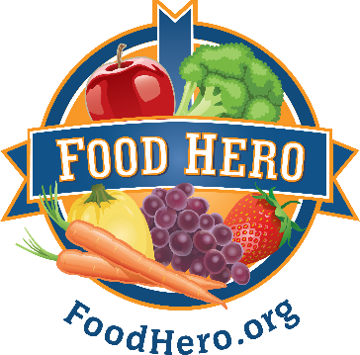
Ingredient

