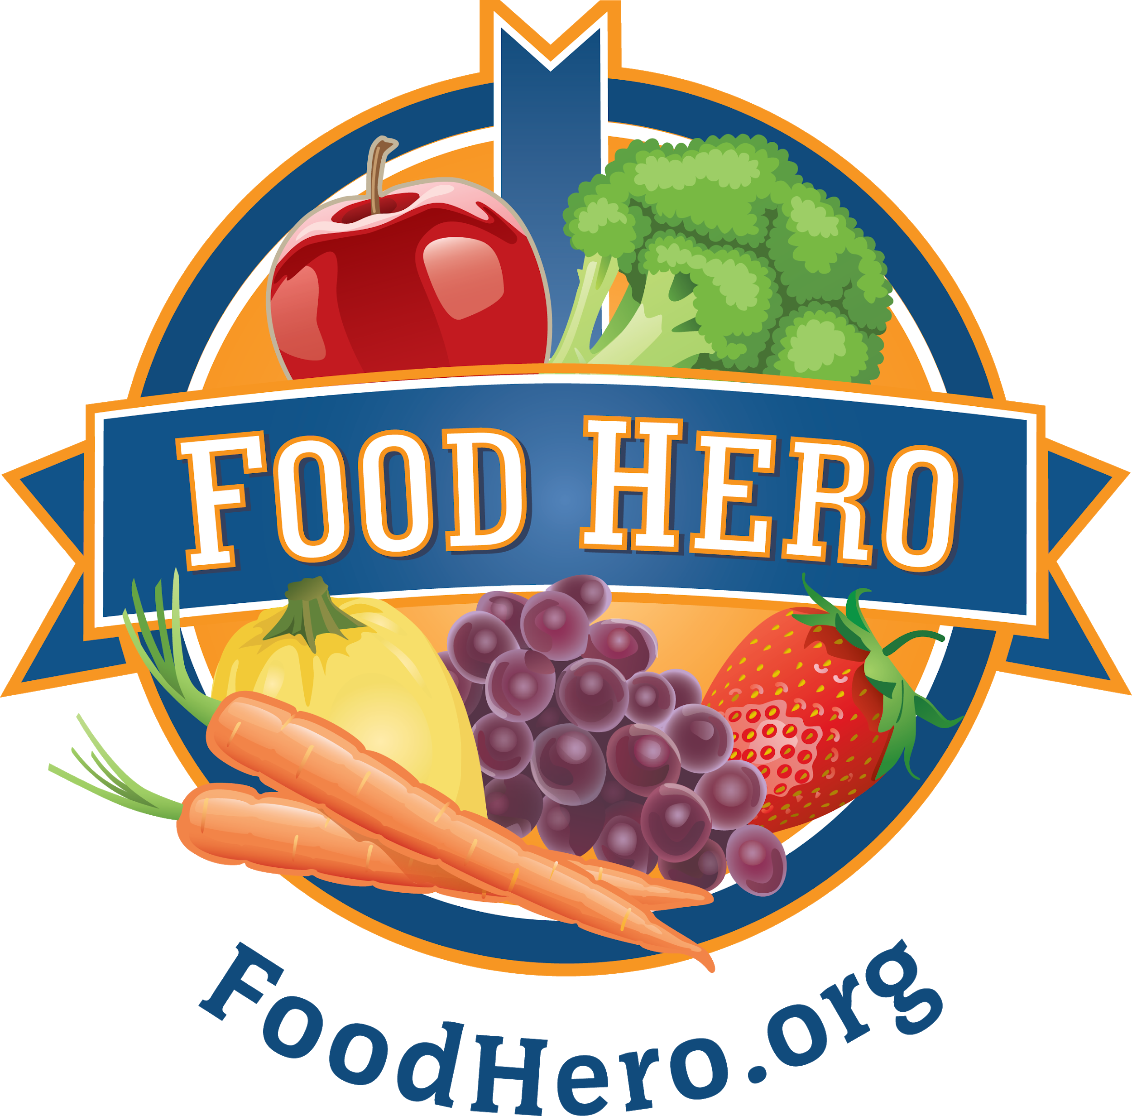

HEALTHY SCHOOL CELEBRATIONS

The Oregon State University Extension SNAP-Ed Program’s Healthy School Celebrations is designed to bring healthy foods and fun activities together at school to make healthy habits the norm. The Healthy School Celebrations strategies assist schools to provide consistent messaging around the school food environment and align with Oregon School Wellness policy best practices.

Linn-Benton SNAP-Ed Classroom Toolkit Contents
- 1 resource Guide (notebook assembled from downloadable materials).
- 1 laminated high speed handwashing poster English/Spanish
- 2 large flexible cutting boards
- 1 spatula
- 1 mixing spoon
- 1 pancake turner
- 1 strainer/Colander
- 1 dry measuring cup set
- 1 measuring spoon set
- 1 mixing bowl
- 1 1iquid measuring cup
- 1 vegetable peeler
- 1 vegetable scrubber
- 1 soap, dish cloth, nail scrub
- 1 storage bag

Linn-Benton SNAP-Ed School level Toolkit Contents

- 1 can opener
- 1 grater
- 6 kid chef knives
- 1 blender
- 1 electric griddle
- 2 large serving trays
- 1 storage box

