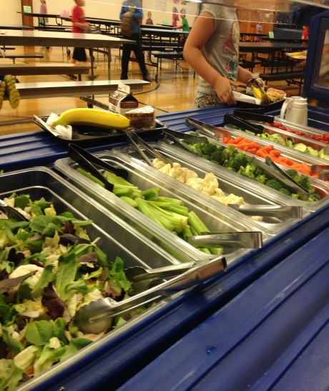
What: Join in on this exciting raffle to reach our goal of $2500 to buy a salad bar for the Glide Elementary School cafeteria. If the goal is surpassed, additional funds will go to the school garden, which will contribute produce to the salad bar. The raffle will be full of great prizes!
Where: Purchase tickets at the Glide Elementary School main office for $5 each.
When: October-November 2017, exact dates to come.

Do you have a raffle donation? Please contact Erin Maidlow at 541-236-3015 or Erin.maidlow@oregonstate.edu.
Why support the Glide salad bar?
  - Research shows that children increase their fruit and vegetable consumption when given a variety of options on a salad bar.
  - When students are allowed to choose their own fruits and vegetables, they are more likely to try new foods and build better eating habits.
