What: OSU Extension SNAP-Ed Benton County and Food Hero will host a free Food Hero Recipe Tasting
Where: 1687 NW Division Street Corvallis, OR 97330

When: 12:30pm – 1:30pm
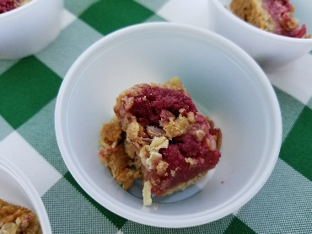
- June 19
- July 3
- July 17
- August 7
- August 21

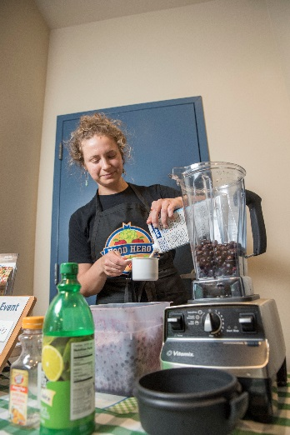
Questions? Call Tina 541-967-3871
The taste includes:
  - A small taste of a recipe from www.FoodHero.org
  - A printed recipe for you to take home.
  - Extra printed recipes to take home.

This material was funded by USDA’s Supplemental Nutrition Assistance Program (SNAP). SNAP provides nutrition assistance to people with low income. SNAP can help you buy nutritious foods for a better diet. To find out more, contact Oregon Safe Net at 211. USDA is an equal opportunity provider and employer. Oregon State University Extension Service prohibits discrimination in all its programs, services, activities, and materials on the basis of race, color, national origin, religion, sex, gender identity (including gender expression), sexual orientation, disability, age, marital status, familial/parental status, income derived from a public assistance program, political beliefs, genetic information, veteran’s status, reprisal or retaliation for prior civil rights activity. (Not all p prohibited bases apply to all programs.) Oregon State University, Oregon State University Extension Service and Food Share of Linn/Benton County are Equal Opportunity Providers. Accommodation requests related to a disability or dietary restriction should be made by June 18 to Tina Dodge Vera by calling 541-730-3541 or by emailing tina.dodge@oregonstate.edu

