A Bingo card promoting healthy behaviors was given to XXX Elementary School students to take home during spring break, 2019. This report celebrates some of the successes of XX of these students. XX of these children completed their Bingo card with a sibling.

Top Reported Healthy Eating
and Activity Behaviors:
- XXX minutes of outside play
- XXX minutes of families walking together
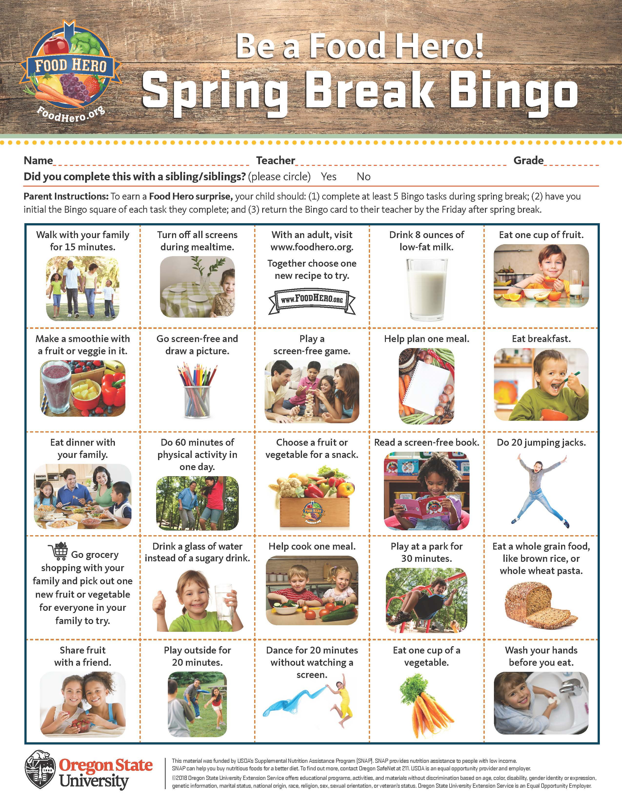
- XX times children washed their hands before eating
- XX cups of fruit eaten during snack time
- XX children chose water instead of a sugary drink
- XXX ounces of low-fat milk consumed
- XX dinners and breakfasts eaten as a family

The Bingo card is available at
http://foodhero.org/bingo-spring-break

