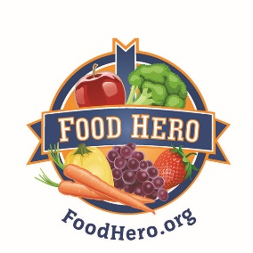
Consent Form
Oregon State University Extension
Kids Art Contest

Dear Parent or Guardian:

OSU Extension Family and Community Health program is currently developing our social media, website and other program materials to be used in our nutrition education program. Our programs promote healthy eating and physical activity. We are in need of drawings from the students participating in our nutrition education programming, and have invited students throughout Oregon to submit artwork. We will choose several pieces that will be used on our Food Hero website, social media, and other educational materials that will be distributed throughout Oregon. All winners will be posted on the website http://foodhero.org/ingredients.

Only artwork that is accompanied by a completed consent form will be considered. We will use the first name of the child, their grade level, and location of the school on any materials we print or publish on the website, but no other identifying information. All entries are the property of Oregon State University Extension and will not be returned. OSU Extension reserves the right to publish the entries in future publications or on the website without notice or compensation.

Please have your child return this form to their classroom. Questions? Contact Lauren Tobey, OSU Extension, 118 Ballard Hall, Corvallis OR 97330
(541) 737-4264, or email lauren.tobey@oregonstate.edu.

NAME OF TEACHER: ____________________________________________________

_____________________________________________________________________________
Student’s Name Student’s Grade

If my child’s art is chosen, I consent to the terms of use of that art by OSU Extension set forth above.

Parent or Guardian Name Parent or Guardian Signature Date

Name of Program or School_______________________________________________________

Name of OSU Extension Instructor _________________________________________________

