How to display a personalized Zoom background

It’s easy to use the OSU Extension Zoom background options (or create your own). You get the best results is you have a green screen background, but not many of us are that prepared. If you’re okay with a little wonkiness around your image, you can easily select an image and upload it to Zoom.

- Select one or more images from the Zoom-Backgrounds folder in Box. There are several backgrounds co-branded for 4-H, Food Hero and Sea Grant. All others have the OSU Extension Service companion logo. Save the .jpg images in a convenient location.
  - Go to the Extension Employee Intranet web page: https://employee.extension.oregonstate.edu/
  - Click on the Marketing Templates, Tools and Inspiration bullet point under Popular Links
  - Look for the Ready to Use folder, then select Zoom-Backgrounds
  - Click on the image you want to save, select download and save it to your preferred location
- When you’re in a Zoom meeting and before turning on your video display:
  - Click on the “^” next to the video icon (probably in the lower left corner of your screen)

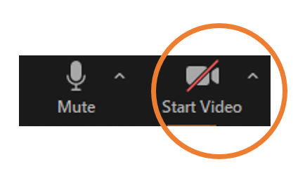
- Click on “Choose Virtual Background”
- Click on the “+”, select “Add image” and follow the prompts to upload the Extension Zoom background(s) you selected in step 1
- Select the image you want displayed. Be sure the “Mirror my video” is selected (or everything will appear backwards).
- Then close the Background & Filters box (click on the “x” in the upper right corner)
- Click on the Start Video icon and you and your new Zoom background will be on display!

