- Drag the picture you want to edit directly to the Photoshop icon on your dashboard. Photoshop will then open up and the picture will be ready to edit. Zoom in on the picture so that it is easier to work with the tiny name tags using the magnifying tool (see red arrow below)
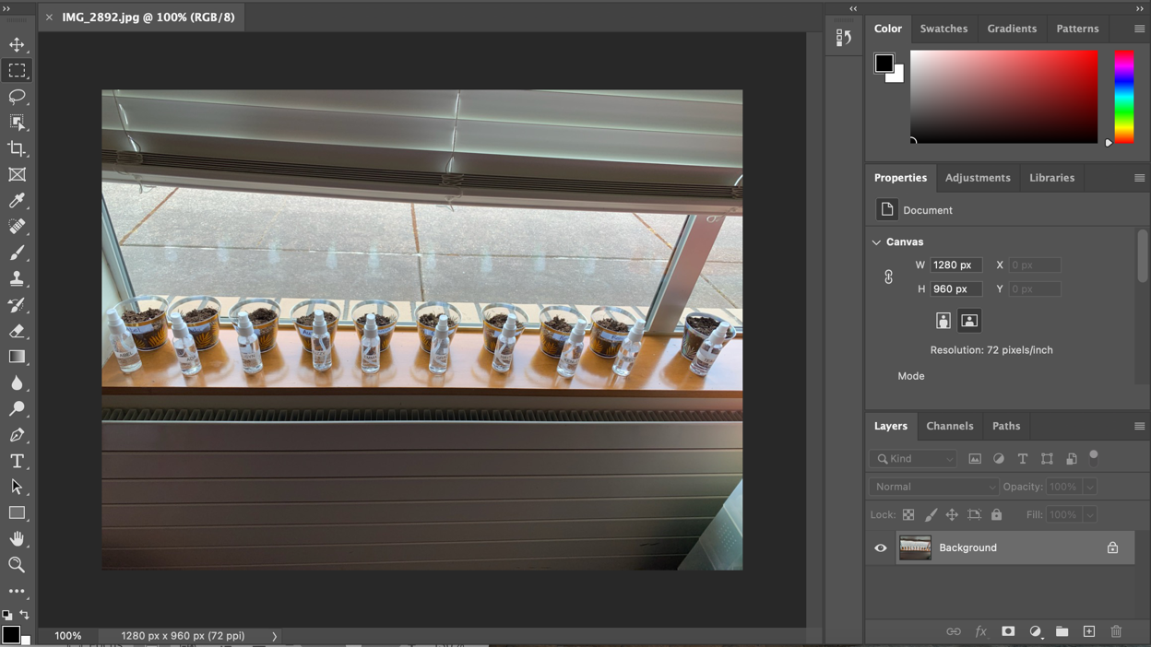

- Then select the rectangular marquee tool or the lasso tool that is in the toolbar on the left. (see blue arrows below) The lasso tool allows you to draw a freehand selection. The rectangular marquee tool will only draw a rectangle. (example below)
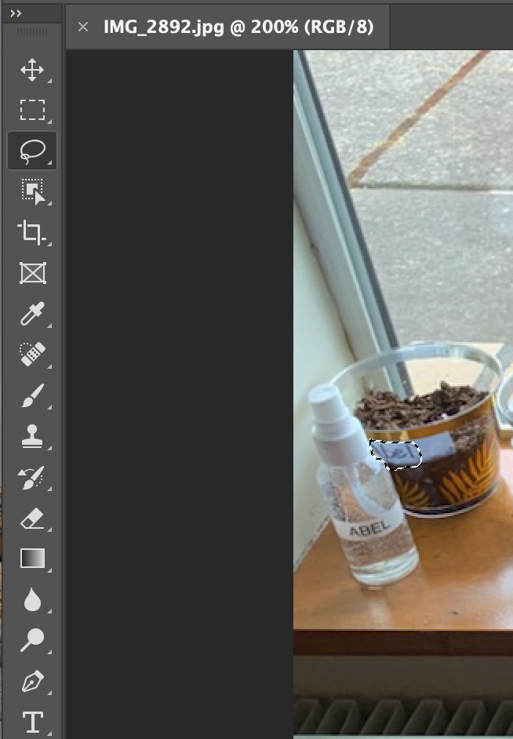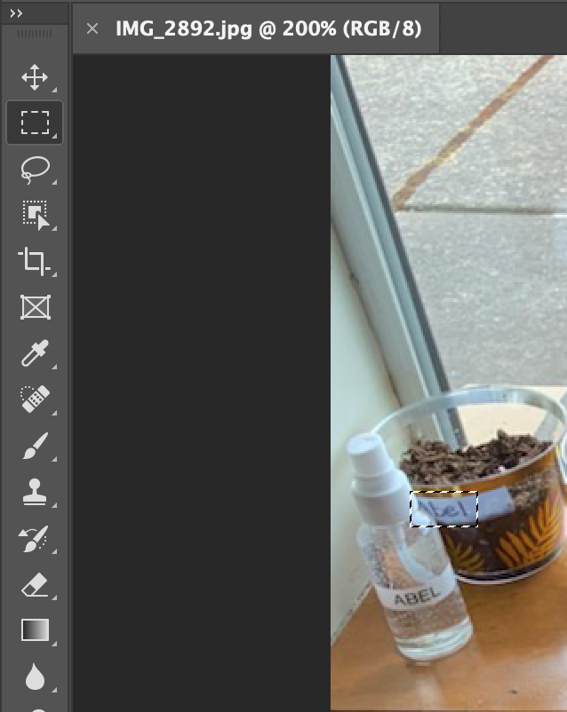
Marquee tool
Lasso tool
- Draw a selection around the area of the image you want to blur. (see blue arrow below) Once you draw the selection around the area and you want to adjust the size/shape of the area you just drew, click anywhere and try again.
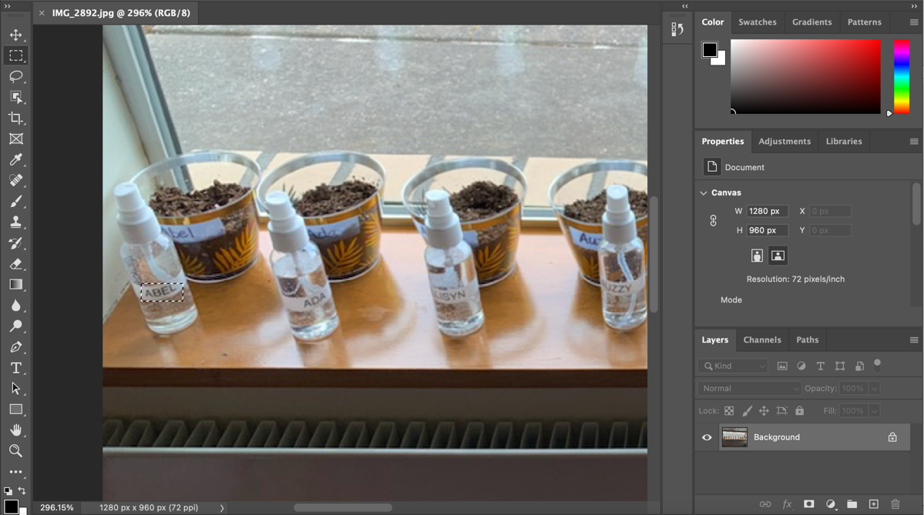

- Then go to Filter > Blur > Gaussian Blur.
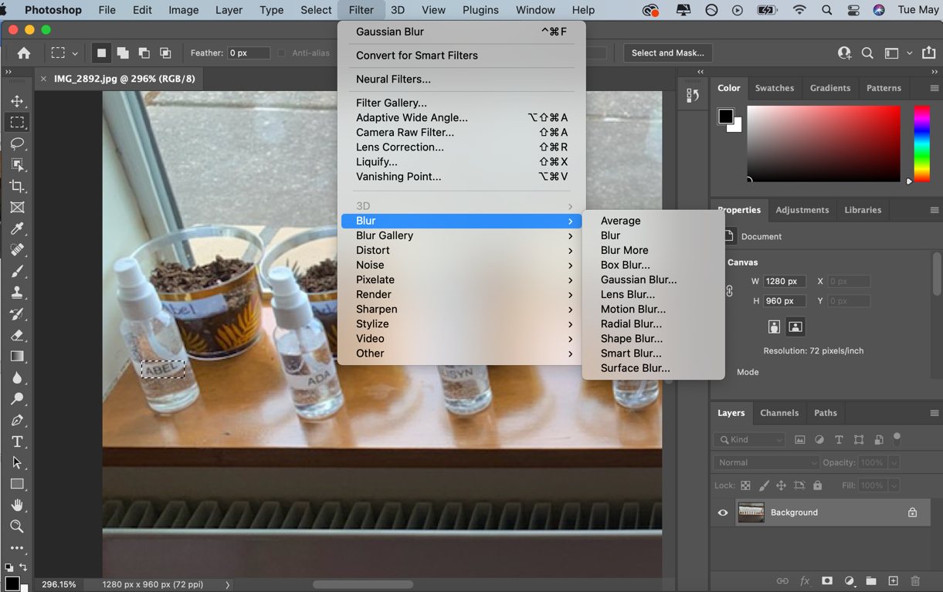

- The Gaussian Blur menu will pop up and you can increase/decrease the radius. (Increasing the radius is what will blur the area you selected. I found that a radius of 5.4 worked to blur the names in this picture) Click OK to apply the effect.
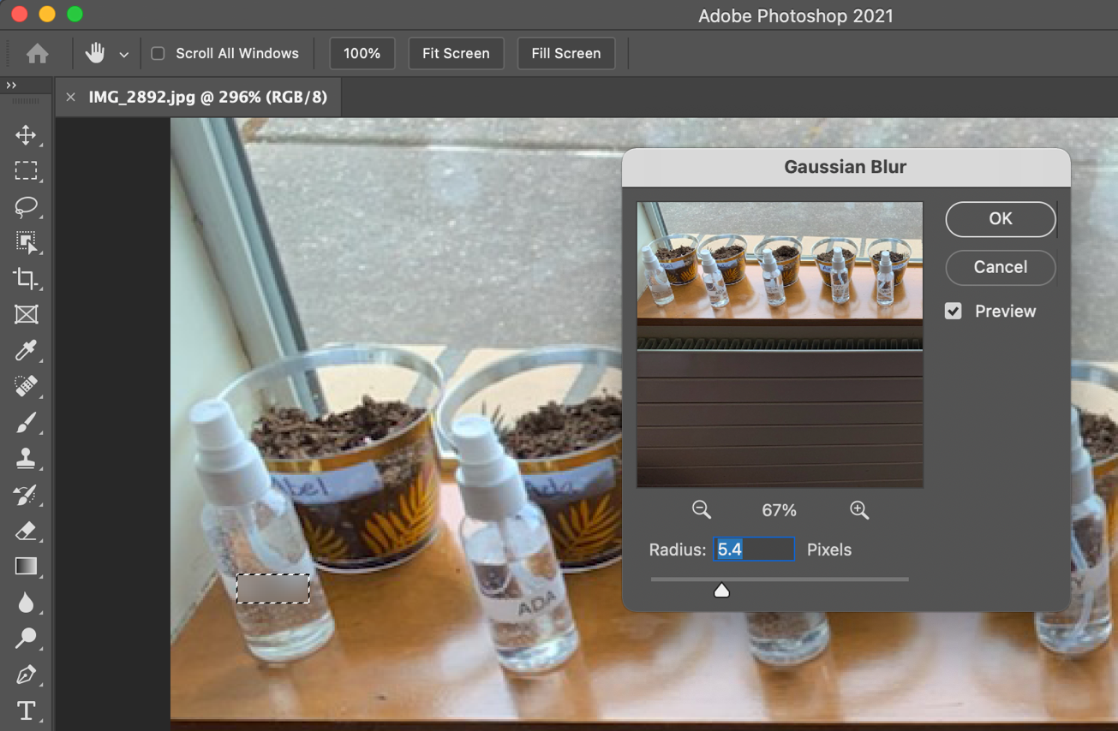

- To keep blurring the names, just repeat the process, but make sure that you are doing it on the same ‘background’ layer. Do not add layers.
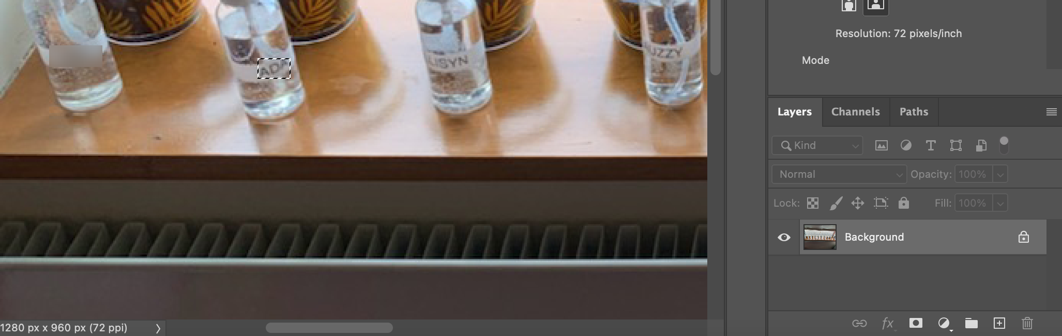

- Save your work by going to File > Save As… to save your Photoshop file. To export as a PNG file, go to File > Quick Export as PNG. 