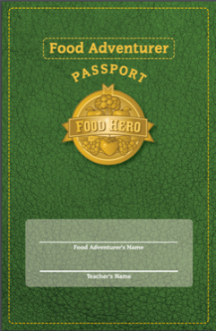
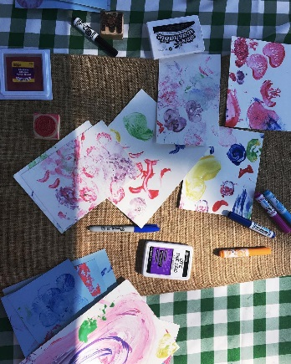
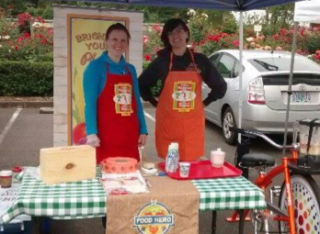
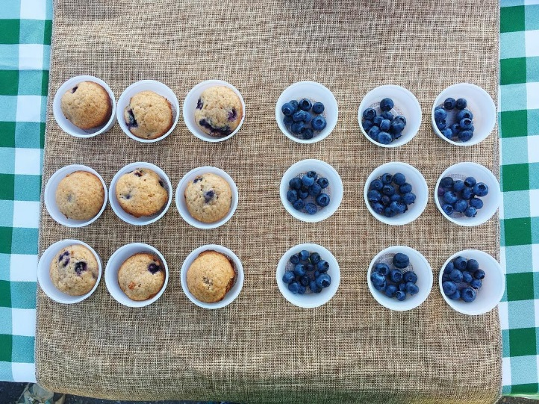
Join Us at the Farmers Market!
At the Food Hero booth, your kids can earn stamps on a Food Hero passport by tasting fruits and vegetables in fun ways, making vegetable art, and going on a fruit and vegetable scavenger hunt. Each week kids participate, they will receive a $2 voucher to spend at the market on fruits and vegetables of their choice. Kids who participate 4 or more weeks will receive a special prize. And we will store the passports at the market so you don’t have to remember to bring them!
Who: All children ages 3 and up
When and Where: June, July and August…

Saturdays 9:00–1:00,  June 1st–August 4th | Umpqua Valley Farmers Market  1771 West Harvard Ave, Roseburg
Tuesdays 3:00–7:00,  June 5th–August 7th | Southside Farmers Market  1614 SE Stephens St, Roseburg
Wednesdays 9:30–1:30,  June 6th–August 8th | Canyonville Farmers Market  Seven Feathers South Parking Lot,  Exit 99, Canyonville
Thursdays 2:00–6:00,  June 7th– August 9th | Lookingglass Farmers Market  7426 Lookingglass Rd, Roseburg

